2.3 I Can Use a Range of Tools and Techniques in the Recommended Way

During the development of my website I have used a range of tools and techniques to ascertain my requirements for the project; breaking down the tasks to be undertaken as well as to track the overall progress of the project

In the initial pre planning stages I decided on the general purpose of my website, deciding on a coffee fan page that would appeal to fellow fans of coffee. I then started to define the project requirements, creating a wire framework of my website and drafting the content that I wanted to include. Once this was established I created a product backlog by breaking down all the tasks that needed to be completed for the website to be completed from the very first step, for example deciding on which source code editor to use, website design and html and css coding.

I then created a Gantt chart outlining these steps in detail, estimating how long it would take to complete each step and identifying which tasks had dependencies, ensuring that work is completed in the right order. Creating a Gantt chart helped me to see how long the overall process would take as well as to give me a scheduled plan of tasks to work to. A screenshot of my website below;

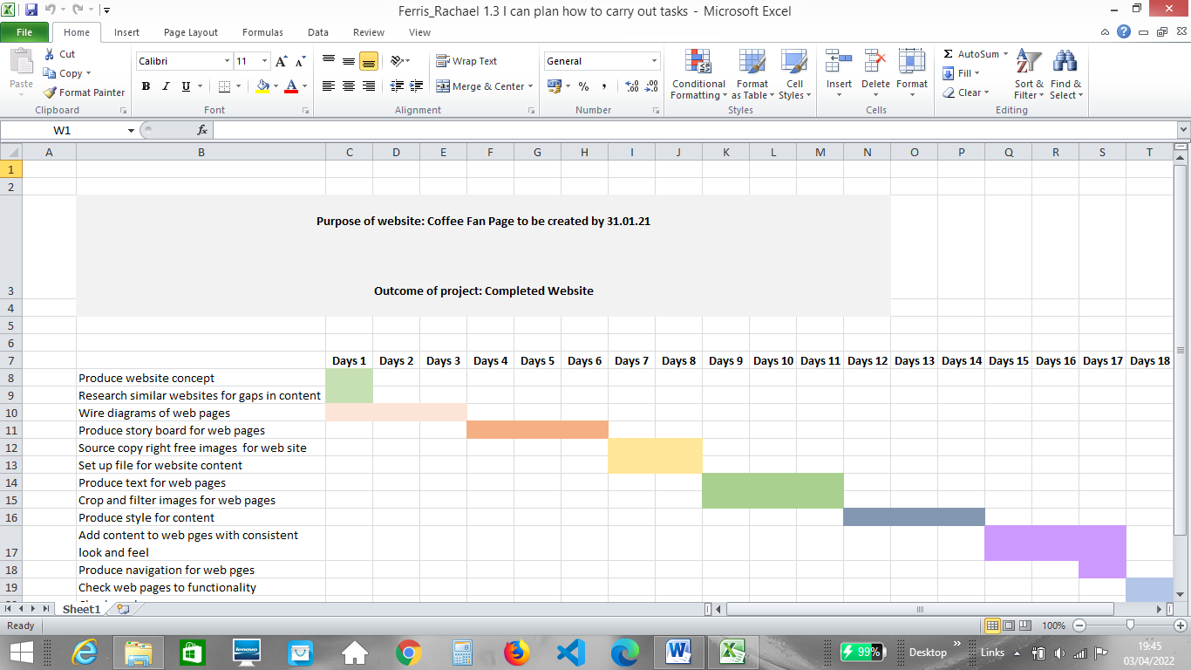

Whilst undertaking the project I have been using Trello to track tasks completed. Using a Kanban template on Trello has helped me to visually identify tasks in progress as well as tasks completed easily, giving me options to assign labels and reminders and give updates on each tasks when work has been carried out. It is also useful for identifying tasks that have been held up due to issues with completing the task such more time needed to complete other dependencies.

Using the Kanban project management method helps me to control my workload as I can limit what is in progress based on my personal work in progress limits (WIP limit) and focus on one task at a time. I can also see if there are any issues with the flow of work if numerous tasks are getting ‘stuck’ in one category on the board. Work is broken down into the following categories on my Trello board;

* **Backlog – a list of possible tasks based on current project requirements**
* **Design and research – Design and research tasks**
* **To do – Tasks that are ready to be worked on**
* **Doing – Tasks that are in progress**
* **Code review – Tasks subject to code review (checking code for mistakes)**
* **Testing – Tasks subject to quality assurance and or/require fixes based on Quality Assurance finds(QA)**
* **Done – Completed tasks**

On a daily basis we have a tutorial with our tutor where we can discuss the status of our work and any blocks that we are experiencing to get the work done. In a workplace environment a quick daily ‘walk the board’ meeting would take place when using Kanban to review the work that is close to completion and then moving right to left on the board reviewing what it is in progress, with the focus on being what can be finished today, tasks that are ‘blocked ‘and progress towards the meeting the sprint goal. Tasks are also assigned in these meetings to developers who have capacity to complete them therefore helping to ensure a quick workflow.